School payments online
As of Jan 21st, 2020, our Kindo online School shop will be our preferred method of payment for your child’s school expenses, and we encourage you to set up your family account today. It’s easy, convenient and open 24/7.
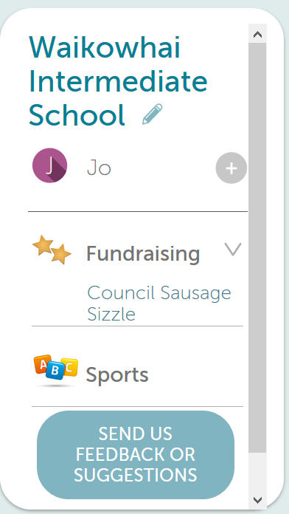
New users
New users can set up an account easily!

Click here and enter in the email address the school has on file for you, then click “continue’.

A confirmation email with a link will be sent to you.

Click on the link and enter a password to complete your registration.

Existing users Already have an ezlunch or Kindo account? Simply login with your email and password and click on the ‘Fees and Donations’ service to link your students to our school records and view your family account.
Click here to log in.

Payment
There are three ways you can choose to top-up your account, and this can be done at the checkout, or by selecting the ‘top up account’ option.

Bank Transfer No fees. Allow 1-3 days for processing.

POLi No fees. Instant transfer.

Credit/Debit Card 50 cent charge + 2.5% fee. Instant transfer.
Visa / MasterCard / American Express / China UnionPay available.

Shopping
From your family account, you can choose to pay the full amount by clicking ‘+’ next to the item or make a part payment, by changing the amount before clicking the ‘+’.

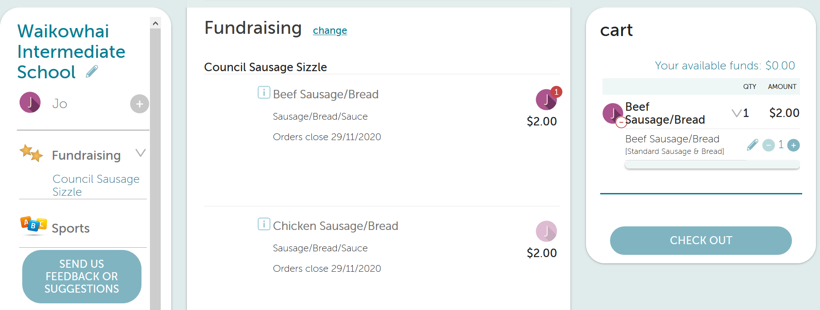
For an optional item, click on your child’s initial next to the item to add it to your cart.

Once you have finished adding items to your cart you can select
Then simply click at the checkout and you’re done!

Your order will automatically go through to the school, and you will receive an email receipt confirming your payment or top-up!
Need assistance
Call the Kindo helpdesk on free phone 0508 4 KINDO (0508 454 636).
We are open Monday to Friday 8am - 4pm

